Evan Tilley

elt2141

User Journey Map – Mushroom Website

**Person Interviewed:** Gina Tilley. Pronoun: F

**User description**: Gina Tilley has, in the past, gathered edible mushrooms and lives nearby many mushrooms. She may want to refresh her knowledge concerning a certain species of mushroom and thus may want a detailed mycological website.

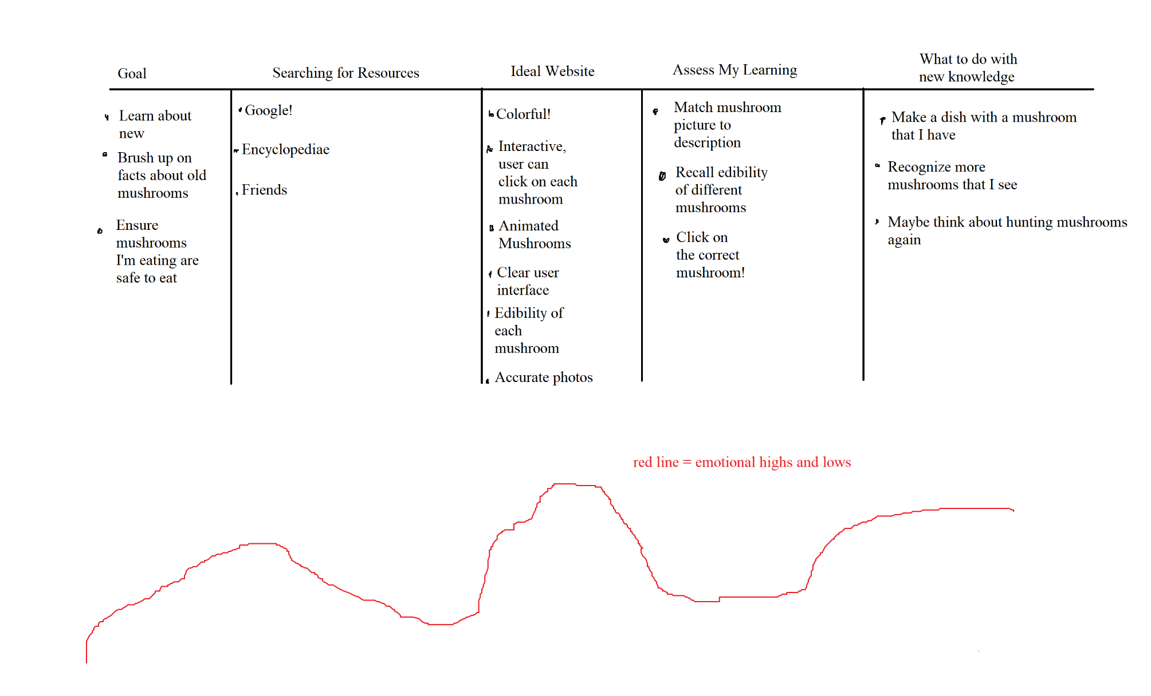

**Insights and Surprises**

This user journey was useful because it let me analyze the needs of a typical user visiting the Mushroom website. I was able to gain insight into what a user wants from the website – including interaction with mushrooms and information desired about the mushrooms (like edibility and species). I was most surprised that the user suggested the idea of matching mushroom pictures to a description because I though this was a very effective way to recognize mushrooms and would be useful in real life. This feature will be implemented in the prototype.